History of Western Civilization

European Society 1450 – 1750 (November 2007)

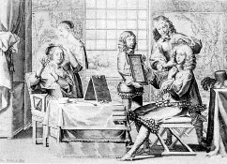

Our current course topics spans from the 15th to the 18th century. Over this time we will be examining the main events that we occurring in Europe and the Western World. While the Renaissance, Reformation, Exploration, Government Systems, and the Scientific Revolution are some of the main focus areas from this era and those are the main topics that we study, what about the development of society and minor events of everyday life? How did Europeans live on a daily basis when it came to such things as music, fashion, food & cooking, and sports & leisure?

In this project we will be moving away from the major course concepts and exploring some of these social trends.

Instructions:

- Navigate to Eras of Elegance, www.erasofelegance.com/history.html

- Explore the three specific time periods listed below:

- The Renaissance Era (1450 – 1600)
- The Elizabethan Era (1558 – 1603)
- The Baroque Era (1600 – 1750)

- Read about popular culture related to each of these eras with particular focus on music, fashion, food & cooking, and sports & leisure

- Develop a common idea, trend, or theme either individually or with a classmate

- Read, understand, paraphrase, begin writing

- Microsoft Publisher Newsletter

- Documentation must be provided for all sources used from the website above. Also document the sites where you acquire pictures or graphics. Citation Machine is a great resource to use when developing your bibliography.

- Evaluation will be based content, original ideas & creativity.

