History of Western Civilization

Unit 3: Exploration and Expansion Newsletter

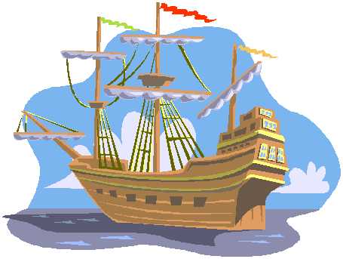

In this unit project you will be using Microsoft Publisher to create a one-paged newsletter about some aspect of European expansion during the Age of Exploration, 1450 – 1650.

You may want to focus on the individuals, the dangers, the ocean voyages, new discoveries, etc. The choice is yours, be creative

Project Components

- 2 articles about some aspect of the Age of Exploration with focus on the individual explorers. Include pictures / graphics to supplement your articles

- Inside this Issue. For this section you only need to develop a list of items that will be included in your newsletter. This will be a table of contents so to speak. You will not need to write stories for these titles. BE CREATIVE

- A Final section called “special points of interest” where you will include a variety of general facts about the Age of Exploration that you find interesting

- BIBLIOGRAPHY…..including a minimum of three sources

STAY ON TASK…….THE MORE TIME YOU WASTE THE LESS YOU WILL HAVE TO COMPLETE THIS PROJECT.

Notable explorers include:

John Cabot Jacques Cartier Samuel De Champlain
James Cook Sir Francis Drake Lief Erickson
Henry the Navigator Marco Polo Giovanna da Verrazano
Henry Hudson Ferdinand Magellan Amerigo Vespucci
Vasco Nunez de Balboa Bartolomeu Diaz Hernando Cortes
Francisco Pizzaro Martin Frobisher John Franklin
Christopher Columbus Juan Ponce de Leon Vasco da Gama

