World War One Trench Warfare
Newsletter

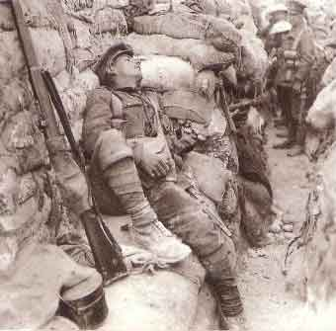

Trench warfare is synonymous with World War One. With the failure of pre-war battle plans in the opening stages of the war, by September 1914 a system of trenches were constructed along the Western Front. Constructed by both the Allies and the Central Powers, these trench systems would eventually stretch for several hundred kilometers from the English Channel to the Swiss border.

In this project you will be conducting research and developing a newsletter using Microsoft Publisher about trench warfare during the First World War.

Project Components

- 2 articles about some aspect of trench warfare (trench description, trench organization, problems encounter by the soldiers, weapons that were used in the trenches, daily life of the soldiers, etc) Include pictures / graphics to supplement your articles

- A Table of Contents. For this section you only need to develop a list of items that will be included in your newsletter. BE CREATIVE

- A Final section called “DID YOU KNOW” where you can include a variety of general facts about trench warfare or some other aspect of WW1.

Sources

In addition to your class handout, the following websites are a great place to find topics of interest for this project.

www.spartacus.schoolnet.co.uk/FWWtrench.htm

www.pbs.org/greatwar/chapters/ch2_overview.html

www.firstworldwar.com/features/trenchlife.htm

