Who Wants to Be a Voyageur?

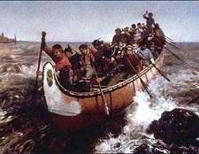

In this project you will be using Microsoft Publisher to create a 3 panel brochure profiling the career of a voyageur working for the North West Company in Canada’s fur trade industry.

Your first step will be to research and collect information about the voyageurs. Listed below are topics to explore in further detail using the websites provided.

daily activities diets
social groupings / divisions working conditions
physical characteristics hardships
transportation leisure activities.

With your research and note taking complete, choose a brochure template from Microsoft Publisher and begin reorganizing your research into a finished product. Be sure to include graphics and images to supplement your text. Ensure that your information is paraphrased from the original text found in the source websites.

The following websites will help provide some insight into the voyageurs

- http://digital.library.mcgill.ca/nwc/toolbar_1.htm ……..click on history and then navigate to The Voyageurs & The Canoe

Voyageurs Problems in the New France Fur Trade
- http://www.civilization.ca/vmnf/popul/coureurs/miseries.htm

More details about the Voyageur and their transportation network
- http://www.canadianvoyageur.com/history.html

Voyageur games
- http://www.whiteoak.org/learning/catmouse.shtml

